User Research
Your Project Toolkit

How to Use This Toolkit
To get started with this toolkit:
- Click File > Make a copy… in the upper-left corner.
- Give the file a title that includes your first and last name.
- Click OK.
- The toolkit is now saved to your Google Drive account, where you’ll be able to edit it.
Your Project Challenge
In this project, you’ll conduct user research and synthesize your findings to produce project deliverables including a user persona and a problem statement.

This toolkit provides resources to help you:
- Write a research plan, including a discussion guide for your user interviews.
- Conduct a competitive analysis.
- Synthesize your research through affinity mapping.

- Create a well-constructed user persona and problem statement(s) to communicate the desired outcome.

Research Plan
A research plan helps us identify key areas we want to investigate further.

PROJECT NAME: Travelers “R” U
RESEARCH PLAN | PREPARED BY: <Wei Da Chen> | <July 6th 2020>
Goals | From this research, I want to learn the following:  - Whether a mobile/web application with curated itineraries alongside transportation logistics will make it more efficient for travel.  - Whether the implementation of a mobile/web application will boost the overall satisfaction of users and increase clients.
Target Audience | My target audience are primarily middle-aged millennials who make over $75,000 per year and are looking for fun travelling.
Research Method | <Surveys>  - Total number of interviews: 5  - Estimated duration of interview: 15 minutes
Recruitment | - Recruiting method: Posted a Google Form on Facebook  - Recruiting cost: $0
Timeline | 7/9/20 - 2 responses to survey  7/10/20 - 3 responses to survey
Budget
  Category | Cost | Amount | Total
  Recruitment | 0.00 | 0.00 | 0.00
  Compensation | 0.00 | 0.00 | 0.00
  Location | Brooklyn | New York | USA
Discussion Guide   | Prepared by: Wei Da Chen | 7/6/20  1. OBJECTIVE  - To better understand and curate the experience of travellers by implementing a mobile/web app dedicated for travel.  2. INTRODUCTION  - Hello! I am an UX consultant for an enterprise that specializes in providing design and technical solutions to travel and transportation agencies.  - And what I’m interested in hearing today is your experience with researching and coming up with personalized itineraries:  - What is easy for you, what you find likeable, and if there are any difficulties or any confusion about it.  - Everything we talk about today is completely confidential. It won’t be shared with anyone outside our internal research team. “Do you mind if I record our conversation for my notes?”  3. ENTICE: Framing Opening Questions  - What is your name?  - What is your age?  - What is your profession?  - Can I ask when designing applications for users, do you often place yourself in their shoes?  4. ENGAGE: Specific Questions (Prepare these ahead of time to ensure consistency across interviews.)  - Working with travel and transportation agencies, what do you mostly look for in terms of appealing to travellers?  - What specific functionality are you or your team currently working on?  - How do you think this application you’re creating will benefit users?  - Can I ask what were some of the confusions when taking on the goal of designing and curating itineraries?  - How would you want the user to feel when visiting this application?  5. EXIT: Final Thoughts (Give the interviewee a moment to wrap up their thoughts.)  - Was there anything else that you would like to tell me about that you haven’t had a chance to say?  6. EXTEND: Follow Up and Next Steps  - Following this interview/survey, we will analyze and compare your findings with other participants to try to map out the main difficulties you guys have in common.  - After we map it out, we will fine-tune and possibly alter the design of the mobile/web application to better fit the needs of your users.  - If we need to request any further information from you, this is my phone number and email.  - I appreciate your time and if there is anyone you know that may be free to interview, be sure to let us know.  - Thank you for your invaluable time.
Notes | <If applicable, insert links to additional notes>

Interview Notes
Use this template to synthesize your interview notes and highlight any emerging themes. Note that the questions provided are examples to guide your thinking.

The three most memorable points from your user interviews:
- Participant 1 sounds really open to sharing as he/she wrote paragraphs detailing his/her experience.
- Participant 2 lives in a family of 4, very charismatic.
- Participant 3 travels for fun as a hobby.
Behaviors  Who is searching for terms related to my category?  - Millennials  - Travellers  - Older age groups | Quotes  What is my audience saying on social media?  N/A
Likes  What’s happening with my audience and category more generally?  - Some of my audience booked vacations months in advance because of cheap flights caused by the pandemic. | Dislikes  What is stopping my audience from further engagement?  - No compensation  - Too much time dedicated to a survey  - No recent or planned travels because of pandemic
Competitive Analysis
To conduct the competitive analysis, you can use one or more of the following methods: plus/delta, task analysis, and feature inventory.
Plus/Delta
Expedia Group | Direct Travel
Positives:  - Travel Discounts for families & friends  - Tests new products continuously  - Uses advanced technologies (Artificial Intelligence & machine learning, eye tracking & face reader technology) to curate the best experience for users.  - Allows you the options of redeeming points for travel  - My Scratchpad feature which allows you to track & save your notes on travel searches  Negatives:  - Inconsistent with hotel reservations | Positives:  - Many supplier relationships which result in great deals  - Always there to help in case of a disaster  - On top of travel trends  Negatives:  - They do not help with finding cheaper airfare

Task Analysis
Fill out the template below to document the tasks you want to analyze and the steps a user must take in order to complete them using a competitor’s product or service. Feel free to include additional tasks and competitors as needed.
Task 1: Book an airline ticket using your travel agency.
Competitor: Expedia Group & Direct Travel

- Look for flights in advance
- Check your travel agency’s website
- Check for stops and choose your seat
- Check for special accomodations
Task 2: Customize your travel itinerary.
Competitor: Expedia Group & Direct Travel

- Gather information online such as: flights, hotels, day trip info, etc.
- Fill in day-to-day info
- Email a digital version of the itinerary to yourself
- Print out or access your itinerary from a smartphone
Task 3: Check for flight status updates, weather forecasts, itinerary reminders, and destination information.
Competitor: Expedia Group & Direct Travel

- Log in to your travel agency’s website or app
- Check for information regarding your flight status
- Check for information regarding weather forecasts
- Check for information regarding itinerary reminders
- Check for information regarding destination information

Task 4: Chat with a travel agent online.
Competitor: Expedia Group & Direct Travel

- Check on your travel agency’s website/app if there is a live chat feature for a travel agent
- Ask about consultation services
- Ask about booking flights
- Ask about resort stays and events

Feature Inventory
Competitor ✅❌ | Live Chat with Travel Agent | Customize Travel Itinerary | Flight Status Updates | Weather Forecasts | Booking Airline Ticket | Track and Save Notes | Travel Discounts
Expedia Group | ✅ | ✅ | ✅ | ❌ | ✅ | ✅ | ✅
Direct Travel | ✅ | ✅ | ✅ | ✅ | ✅ | ❌ | ✅
Booking Holdings | ❌ | ❌ | ✅ | ✅ | ✅ | ✅ | ✅
BCD Travel | ✅ | ❌ | ✅ | ✅ | ✅ | ❌ | ✅
Flight Centre | ✅ | ✅ | ✅ | ❌ | ✅ | ❌ | ✅
Fareportal | ✅ | ✅ | ❌ | ✅ | ✅ | ✅ | ✅
Travel and Transport | ✅ | ✅ | ✅ | ✅ | ✅ | ❌ | ✅
Omega World Travel | ✅ | ❌ | ✅ | ✅ | ✅ | ✅ | ✅
Affinity Mapping
Include a representation of your affinity map below. This can be a photo or a digital version of your affinity map with the grouping titles clearly visible. Alternatively, you can simply fill in the following templates with grouping titles plus bullet points representing each observation.

<If available, include a photo of your affinity map here. Otherwise, fill in the template below.>
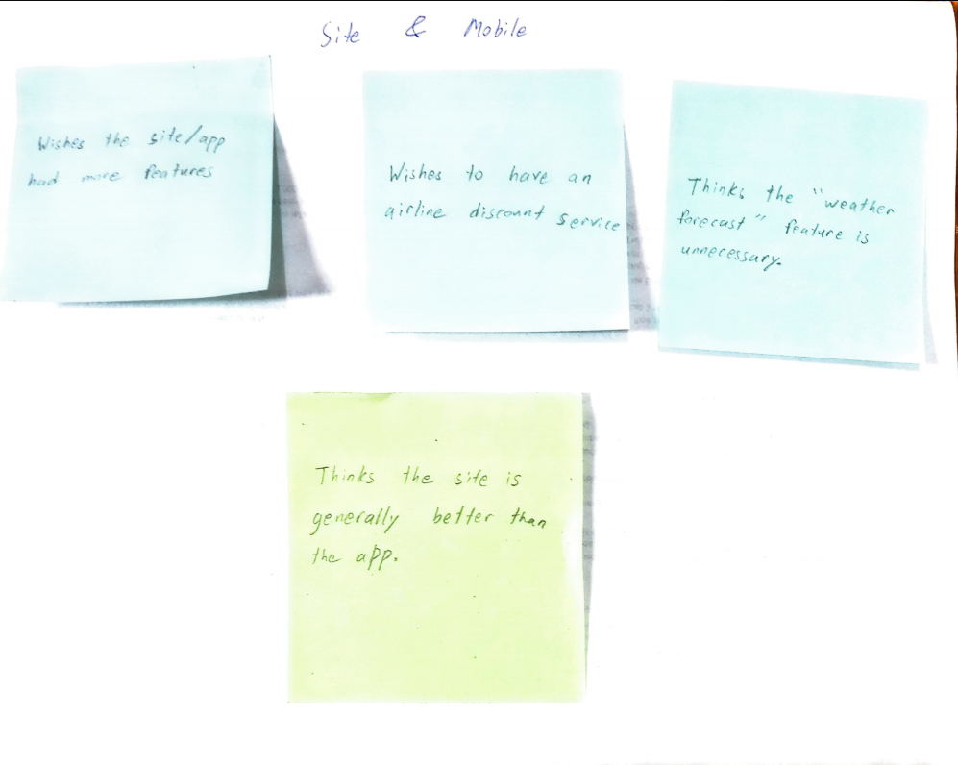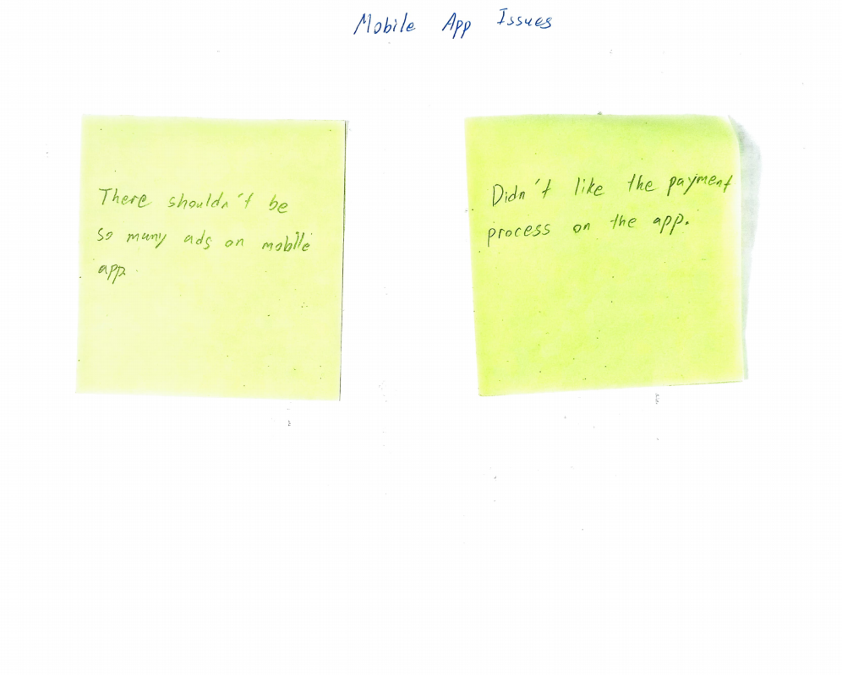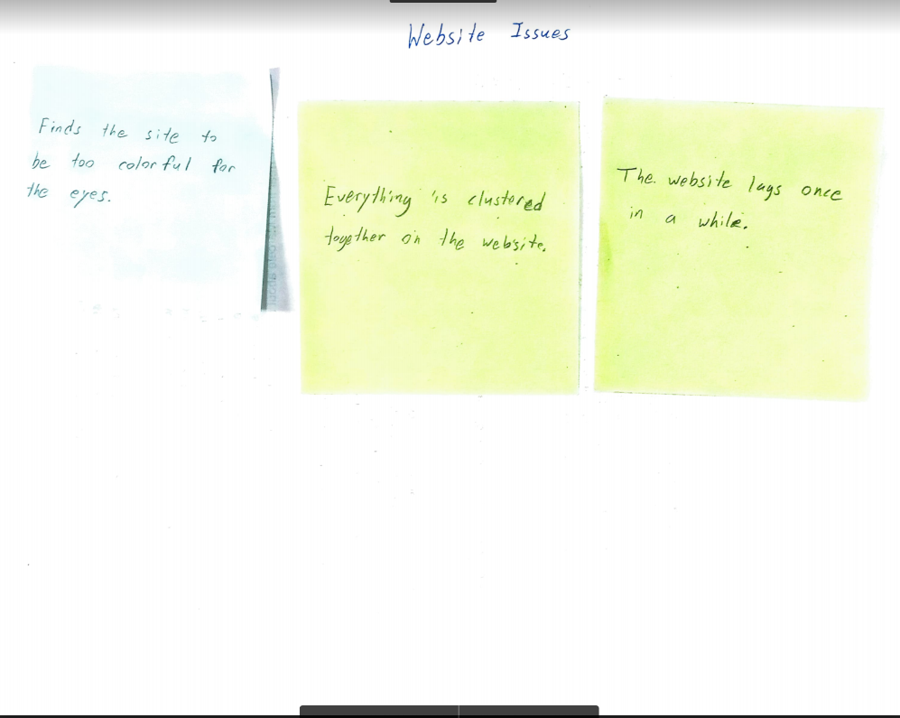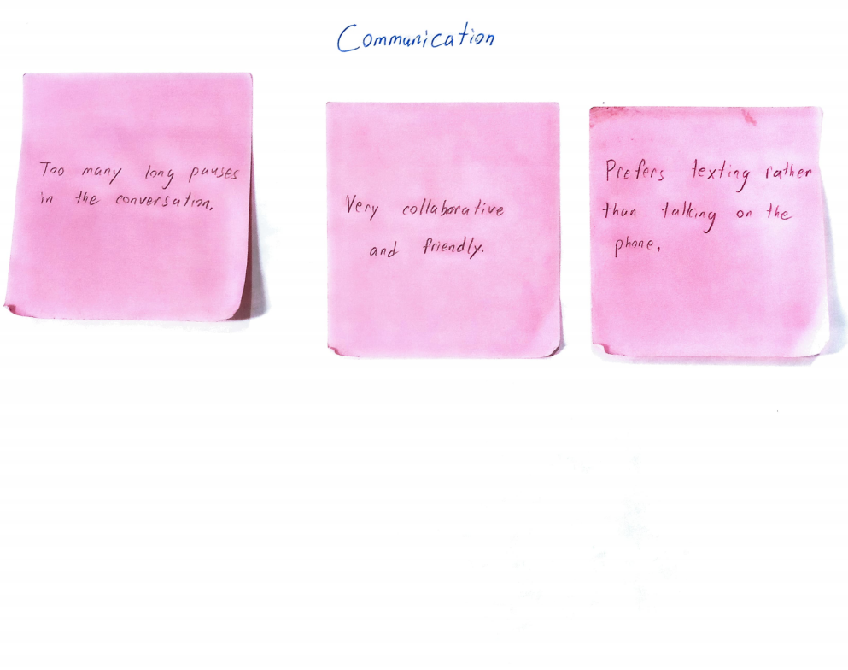

<Grouping title> | <Grouping title> | <Grouping title>
- <Observation>  - <Observation>  - <Observation>  - <Observation> | - <Observation>  - <Observation>  - <Observation>  - <Observation> | - <Observation>  - <Observation>  - <Observation>  - <Observation>
<Grouping title> | <Grouping title> | <Grouping title>
- <Observation>  - <Observation>  - <Observation>  - <Observation> | - <Observation>  - <Observation>  - <Observation>  - <Observation> | - <Observation>  - <Observation>  - <Observation>  - <Observation>

Noticeable trends (Try writing them using “I” statements.”)

- I prefer the website format to be more simplified while enlarging certain elements to make it easier for the user to identify.
- I prefer more services to provide discounts.
`

Create a Persona
Use the following template to create a persona you care about — someone with whom people can empathize.

 | Kevin Chen  Quote | Demographics  Age: 28  Gender: Male  Income: $92,000  Location: Brooklyn, NY, USA
Needs and Goals  - Keep learning, developing new skills, and making many more friends  - Save for early retirement  - Own a business | Challenges/Pain Points  - Hard to personalize or custom-make itineraries on certain travel platforms  - Under-performing APIs (the efficiency of booking depends on APIs that provide access to reservations, flights, weather forecast, etc.)  - Instant access to accurate, up-to-the-minute information can be hard during peak times
Behaviors
- Travels whenever he is free
- Loves to hang out with friends
- Visits his family members whenever he cans

Problem Statements
Problem statement = {User/persona name} needs a way to {user’s need} because {insight}.

Problem Statement | Travellers need access to a more personalized travelling experience including better personalized itineraries to be more efficient because they want to make the most of their time possible.
Problem Statement | Product designers need to more readily appeal to travellers by customizing their travel itineraries to stay on top of the industry because that is what their competitors are doing.
Problem Statement | Travellers need a way to view their itineraries alongside transportation logistics to travel more effectively because they like simplified processes.

Quality Checks
Congratulations! You’ve just completed your user research project. Now it’s time to give your two project deliverables a thorough review before sharing them with your mentor and/or peers. Review the bullets below to ensure that your deliverables meet basic expectations.

Deliverable 1: User Persona

Meeting Expectations
- The persona is appropriately identified and crafted using insights from interviews and affinity mapping.
- The persona is clearly organized and includes a photo, basic demographic information, needs/goals, challenges/pain points, and behaviors.

Deliverable 2: Problem Statement(s)

Meeting Expectations
- The problem statement is properly focused in scope and backed by the user research conducted.
- The problem statement describes the problem (not the solution) in the context of the persona, including its name, user needs, and insights.

